

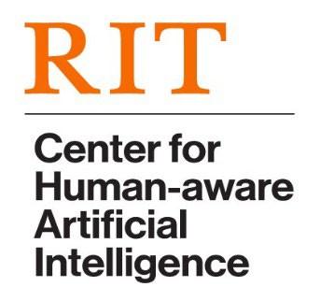

CHAI Seminar Series

*RIT only event. Refreshments will be served.*

# **DATE:** Monday, October 17, 2022, 12:00-1:00 PM

**SPEAKER:** Jhair Gallardo

# Ph.D. Student, RIT Chester F. Carlson Center for Imaging Science

**TITLE:** **Classifying Images By Combining Self-Supervised and Continual Learning**

**IN PERSON: Golisano Hall, Room 2400**

**ABSTRACT:** Self-supervised learning algorithms are trained without labeled data. After training, these systems can be used to create embeddings for downstream tasks. Self-supervised learning has revolutionized natural language understanding, and these methods now rival supervised learning for vision tasks. Continual learning algorithms learn incrementally from a training dataset, without the ability to loop over or observe the entire dataset. Little work has been done on the intersection between self-supervised and continual learning. This talk will review self-supervised learning algorithms and then discuss Jhair’s work demonstrating that self-supervised learning can be used to improve continual learning, including extensive experiments using the ImageNet dataset. Time permitting, Jhair will outline a roadmap for his view of how continual learning and self-supervised learning can be more tightly interwoven.

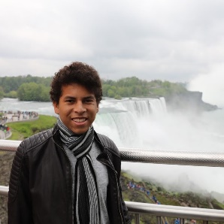**BIO:**  **Jhair Gallardo** is a Ph.D. Student at the Chester F. Carlson Center for Imaging Science, Rochester Institute of Technology (RIT), under the supervision of Dr. Christopher Kanan.  His current research focuses on deep learning with an emphasis on self-supervised learning, continual learning, and computer vision. Jhair’s work has been published at the British Machine Vision Conference (BMVC). Previously, Jhair held a Machine Learning Engineer position at Everis (Lima, Peru) working on deep learning applied to computer vision and recommendation systems. Jhair has also worked as a Deep Learning Intern Scientist at Siemens Healthineers (PA, U.S.) developing deep artificial networks for medical image classification. He received a BS in Mechatronics Engineering from the National University of Engineering in Lima, Peru.

[**https://www.rit.edu/chai/**](http://www.rit.edu/chai/)